Web Time Entry Directions: Students & Part-time Classified Employees

**Time Sensitive: You must submit your signed timesheet by the 20th of every month**

- Login to myClackamas.

- Select the right tab (Student, Staff, etc.) based on your position.
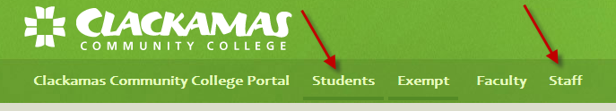

- For Students, under CougarTrax tab, select Student Employee Information, or under Staff tab, select Employee Information from CougarTrax tab.
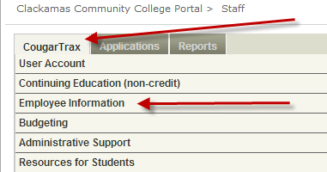
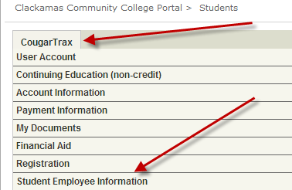

- Select Time Entry.
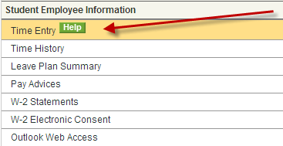

- Select the appropriate position.
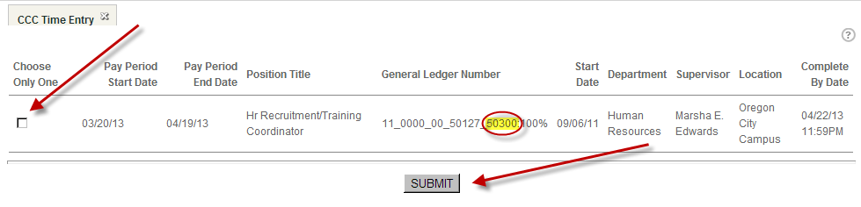

If you are a student with 6+ credits, then the position will have Student in the title and the GL will end in 50410.
If you are taking less than 6 credits or are not a student, then the position will have Part-time Classified in the title and the GL will end in 50340.
If you do not see the correct position(s), contact HR (503-594-3458)!

Click on Submit.

- Enter your time every day you work.
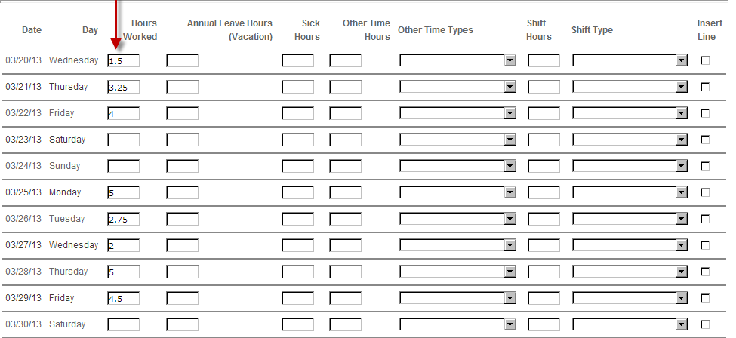
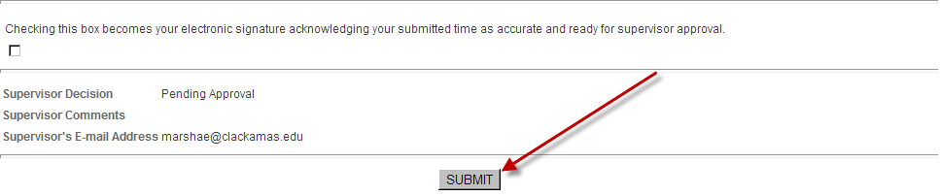

Only enter time in the Hours Worked column.
You can enter your time in 15-minute increments (1.25, 1.50, 1.75, etc.)

As a student or part-time classified employee, you can only work up to 19.5 hours/week between all positions.

After you enter in your time, select the Submit button to save your timesheet.

- You will receive a confirmation page. This is a brief summary of the time you have submitted so far. Select OK.
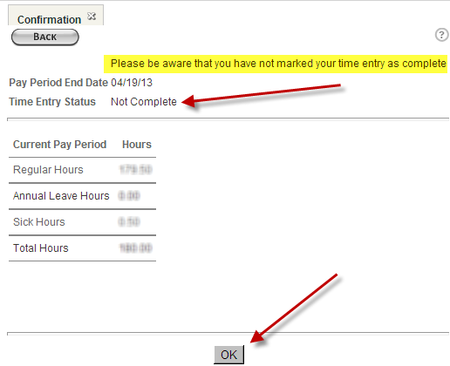

Time Entry Status will show as Not Complete until you have electronically signed and submitted your timesheet at the end of the month.

- You can now logout.

- When submitting your timesheet to your supervisor, sign the timesheet by clicking on the signature box.
Remember to submit your time before leaving for break (e.g. Spring Break), the deadline is the 20th of each month – no exceptions.
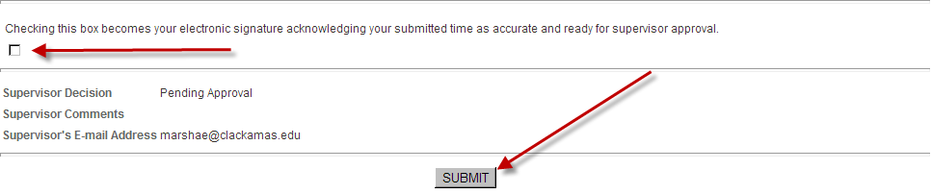
If you mistakenly perform this step before timesheets are due, contact your supervisor.

- You will receive a confirmation page displaying a summary of time. Select OK.
Your timesheet will no longer be accessible to make changes.
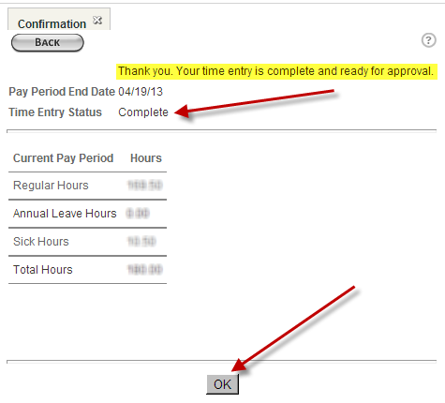

- You can now logout.

- You will receive an email from your supervisor indicating that your time has been approved. The process is complete!
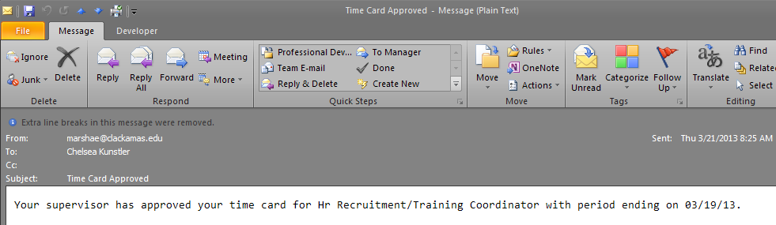

Additional Information:
To review past timesheets, select Time History. Select the appropriate year and select Submit. Select the appropriate position and select Submit. Review your time.
If you signed up for direct deposit, you can review your pay stubs by selecting Pay Advices. Current year displays, or select appropriate year and select Submit. Select appropriate month. Review your pay stub.

To sign-up for electronic W-2 Statements, select W-2 Electronic Consent. To consent means you will not receive a paper W-2 statement. Select appropriate option and select Submit.

After you’ve given consent, select W-2 Statements for previous years worked. Select appropriate year.
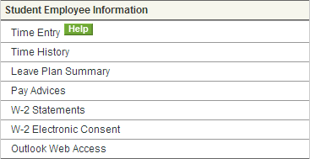

Payroll and HR Contact Information:

Payroll: Michelle Dodgion, 503-594-3092, mdodgion@clackamas.edu
HR Generalist: Vicki Hedges, 503-594-3087, vickidu@clackamas.edu
HR Generalist: Chelsea Lee-Kunstler, 503-594-3301, chelseak@clackamas.edu
HR Generalist: Sara Simmons, 503-594-3303, saras@clackamas.edu
Director of HR: Carrie Loewen, 503-594-3457, carriel@clackamas.edu
Dean of HR: Patricia Anderson Wieck, 503-594-3300, patricia.anderson@clackamas.edu

