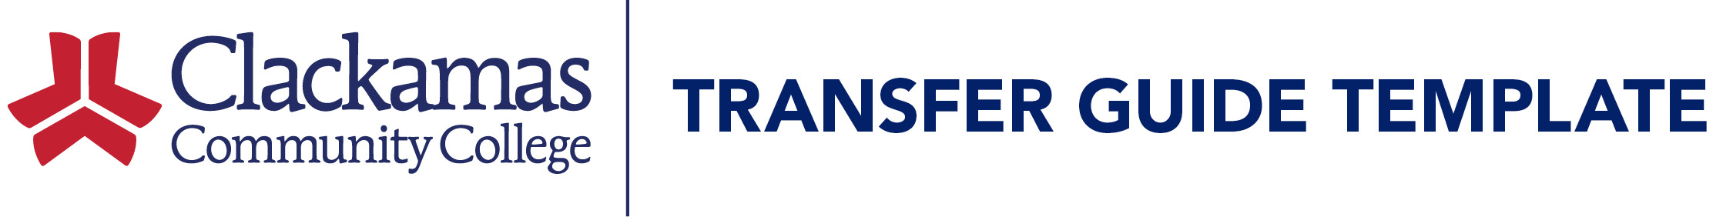
Department Name – Health Sciences
Transfer Guide with Chemeketa Community College
Purpose: Hemodialysis Technician Program
Clackamas Community College  General Education Requirements | Chemeketa Community College  Hemodialysis Technician Program
Program/Major Requirements:
CCC Courses | Quarter Credits | Chemeketa Community College Course Equivalents | Quarter Credits
WRD 090 Introductory College Reading and Writing or higher | 5 | WRD 090 Fundamentals of Writing | 4
MA 110 Medical Terminology | 3 | HM 120 Medical Terminology I | 3
MTH 060 Algebra 1 or higher | 4 | MTH 060 Introductory Algebra | 4
Any Psychology 100 level or higher | 4 | PSY 101 Psychology of Human Relations or higher | 4
TOTAL CLACKAMAS DEGREE CREDITS | 16 | TOTAL CHEMEKETA DEGREE CREDITS | 15

Additional Requirements for Program/Major:
High School Diploma or GED from an accredited institution. Must be a citizen or legal resident of the United States. Placement into MTH 060 (or completion of MTH 020) or higher. Placement into RD 115 (or completion of RD 090) or higher. Placement into WR 090 (or completion of WR 080) or higher. In addition to Writing, Medical Terminology, Math, and Psychology, students will complete HEM101 and HEM102 at Chemeketa to earn a certificate of completion.
In addition to the departmental requirements listed above, students must also complete coursework for university admission, general education requirements and BA/BS requirements. Meet with a Chemeketa Community College Academic & Career Coach to develop an effective transfer plan that will meet your individual needs.
General Education Requirements:

- WRD 090 or higher
- HM 120 or higher
- MTH 060 or higher
- PSY 101 or higher

